DELIVERABLES

1. Complete Use Case diagram.
2. Use Case descriptions.
3. Class diagram of entity classes.
4. Key boundary classes and control classes.
5. Sequence diagrams of some use cases.
6. Initial Dialog map.

**Use Case diagram**

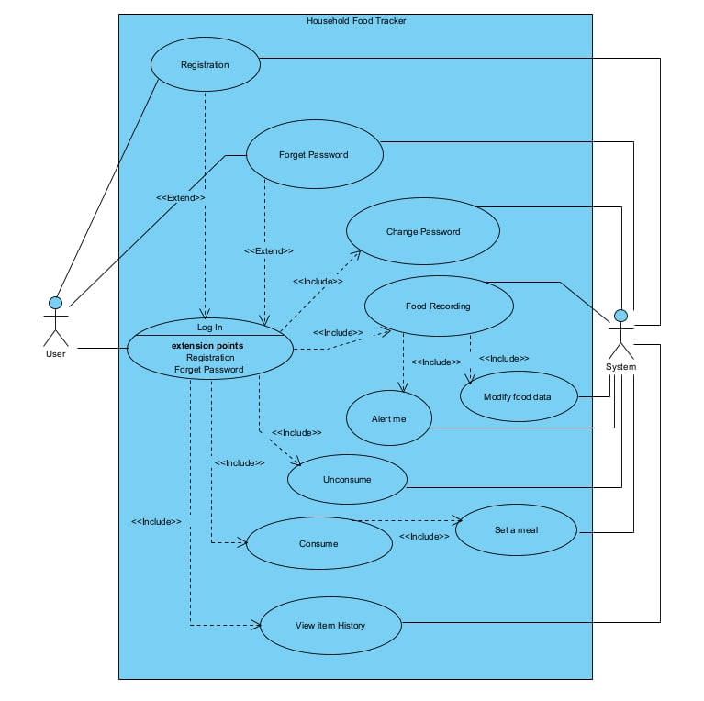

**Use Case descriptions**

Use Case 1: Login

| Actor: | User and System |
| --- | --- |
| Description: | This use case depicts how users login into an existing account. |
| Trigger: | Click on “login” with inputs username/email and password |
| Preconditions | 1. User’s device should have access to the Internet(WIFI/4G)  2. User should have an existing account |
| Failed End condition | 1. Invalid email/ username was given by the user.  2. Wrong corresponding password to valid email/username  3. Having more than three failed login attempts |
| Basic Flow | 1.Users enter email/username and password  2.Users click on “login” button  3.System checks the validity of username/email with system records  4.System checks whether password corresponds to valid username/email  5.System redirects user to enter main login page |
| Alternate Flow | Scenario 1: Invalid email/ username was given by the user  1.System will display an error message.  2.Return to step 1.  3.User need to re-enter all login information.  Scenario 2: Wrong password to valid corresponding email/username  1.System will display an error message  2.Return to step 1  3.User has to re-enter password  Scenario 3: 3rd login attempt failure  1. System will lock the user account  2. Email will be sent to the user's email address |
| Post conditions for basic flow | 1. User will login to existing account |
| Post condition for alternate flow | 1. User's account will be locked and email will be sent to the email address |
| Frequency of occurrence | Very high |
| Special Requirement |  |

Use Case 2: Registration

| Actor: | User, system |
| --- | --- |
| Description: | This use case depicts how users create a new account. |
| Trigger: | Click on “create a new account” |
| Preconditions | 1.User device should have access to Internet(WIFI/4G)  2.Email has not been used for an existing account |
| Failed End condition | 1. This user account already has an existing account under this email address.  2. Users input password does not meet password requirements   * Minimum 8 characters * One uppercase character * One special character |
| Basic Flow | 1.Users enter email, username and password.  2.Users click on “create a new account”.  3.System receives users information.  4.System check if this new account is valid. (valid condition: unique username, email has not been used before to create an account)  5.A new user account is created. |
| Alternate Flow | Scenario 1: Step 4 fails  1.System will display an error message.  2.Users need to re-enter information.  3.Return to step 1. |
| Post conditions | 1.New user account is added to the database successfully.  2.A verification email is sent to the user. |
| Frequency of occurrence | Once a lifetime |
| Special Requirement |  |

Use Case 3: Forgot password

| Actor: | User,System |
| --- | --- |
| Description: | This use case depicts how users change passwords if he/she is unable to log in from the log in page. |
| Trigger: | Click on “Forget password” on login page |
| Preconditions | 1. Need an existing account |
| Failed End condition | 1.This user account cannot be found in the database.  2.Password condition(min X char, 1 upper, 1 special char) |
| Basic Flow | 1.Users click on “forgot password”.  2.System ask for user’s email/username  3.System verify input from step 2  4.System send email to user  5.User clicks the link to change the password in the email and enters a password that fulfills the password condition  6.System records new password  7.user can proceed to login with new password |
| Alternate Flow | Scenario 1: Step 3 fails  1.System will display an error message.  2.Users need to re-enter email/username.  3.Repeat step 3.  Scenario 2: Step 5 fails  1.System will display an error message if conditions for password are not met.  2.System prompts user to re-enter a new password  3.Return to step 7. |
| Post conditions | 1.New password is updated to the account successfully. |
| Frequency of occurrence | As required |
| Special Requirement |  |

Use Case 4: Change password

| Actor: | User,System |
| --- | --- |
| Description: | This use case depicts how users change passwords from account settings from login main page |
| Trigger: | 1.Click on “Change password”  2.System prompts for password change (if password has been used for to long - 6 months) |
| Preconditions | 1. need to be already logged in  2. enter old password  3. User device should have access to Internet(WIFI/4G) |
| Failed End condition | 1. password invalid |
| Basic Flow | 1.User at main login page  2.User click on “Change password”.  3.User enters old password.  4.Verify old password  5.User enters a new password.  6.System check if this new password is valid.  7.System updates account information. |
| Alternate Flow | Scenario 1: Step 4 fails  1.System will display an error message.  2.Users need to re-enter password.  3. if password does not meet conditions,return to step 3  4.return to step 5 if successful  Scenario 2: Step 5 fails  1.System will display an error message.  2.Users need to re-enter a new password.  3. if password does not meet conditions,return to step 5  4.return to step 7 if successful |
| Post conditions | 1.New password is updated to the account successfully. |
| Frequency of occurrence | As required |
| Special Requirement |  |

Use Case 5: Food Recording

| Actor: | User,System |
| --- | --- |
| Description: | This use case depicts how users record the food they purchased. |
| Trigger: | Click on “Start Recording” |
| Preconditions | User device should have access to Internet(WIFI/4G)  User must logged in to their accounts  User must click purchased item button |
| Failed End condition | 1. update purchased items when there is no food items (no food error)  2. Spoonacular does have the product info |
| Basic Flow | 1.Users click on “Start Recording”.  2.Users enter the name of the food they purchased.  3.Users enter the Qty/Balance of the food they purchased.  4. Spoonacular will get id of item user enters  5. Using the id and qty purchased, spoonacular will get calorie information  6. refer to alert use case model  7. user clicks “Finish”  8. System verifies information  9. system updates purchased item list |
| Alternate Flow | Scenario 1: step 8 fail  1. System display no food error  2. return to step 2  Scenario 2: step 4 fails  1. System prompt user “do you want to add calorie information”  2. if yes user enter calories  3. if calories entered is not a number repeat step 2  4. if no calories will be NULL  5. return to step 7 |
| Post conditions | 1.New record is updated to the user account successfully.  2.System will display “Congratulations! record successfully!”  3.The status of each item in this new record will be “In Progress” |
| Frequency of occurrence | As required |
| Special Requirement |  |

Use Case 6: Alert me

| Actor: | Users and System |
| --- | --- |
| Description: | This use case depicts how the system can inform user if an item needs to be consumed |
| Trigger: | User click on “alert me” |
| Preconditions | User device should have access to Internet(WIFI/4G)  User must login to their accounts |
| Failed End condition | User did not make any alert options before clicking “finish” |
| Basic Flow | 1.Users click on “alert me”.  2. System has 2 alert options: category alert and individual item alert.  3.1 user selects category alert eg veg must be consumed 3 days after purchase  3.2 user selects individual item alert eg yogurt must be consumed 2 days after purchase  4. use click “finish”  5. system will save alert settings  6. system will sent user an email a day before |
| Alternate Flow | Scenario 1: step 4 fail  1. System prompts user  2. returns to step 2 |
| Post conditions |  |
| Frequency of occurrence | As required |
| Special Requirement |  |

Use Case 7: Modify food data

| Actor: | Users and System |
| --- | --- |
| Description: | This use case depicts how the user can modify purchase items list if mistakes was made |
| Trigger: | User click on “modify” |
| Preconditions | User device should have access to Internet(WIFI/4G)  User must login to their accounts |
| Failed End condition | User did not make any change before clicking “finish” |
| Basic Flow | 1.Users click on “modify”.  2.Users select the food they owned in their record.  3.Users input the Qty/Balance they want to change.  4.User clicks “finish”  5. System updates purchased item list |
| Alternate Flow | Scenario 1: No change made before step 4  1. System prompts user  2. returns to step 2  Scenario 2: item was already consumed ie balance reach 0  1.System prompts user  2.System will ask user to confirm  3. if confirm, changes will be made  4. return to step 5 |
| Post conditions | 1. balances of food items modified will change according to user’s input |
| Frequency of occurrence | As required |
| Special Requirement |  |

Use Case 8: Consume

| Actor: | Users and System |
| --- | --- |
| Description: | This use case depicts how the system deducts items user consumed |
| Trigger: | User click on “Consume” |
| Preconditions | User device should have access to Internet(WIFI/4G)  User must login to their accounts |
| Failed End condition |  |
| Basic Flow | 1.Users click on “consume”.  2.Users select the food they owned in their record.  3.Users input the Qty they want to eat in this meal.  4.1 User clicks consume  4.2 user clicks set a meal  5. System displays a window of all items consume and total calories of all items  6. System deducts item used, and updates balance of each item used |
| Alternate Flow |  |
| Post conditions | 1.Food consumption is updated to the user account successfully.  2.System will display “Congratulations! Good meal!”  3.The balance of food will be reduced. |
| Frequency of occurrence | as required |
| Special Requirement |  |

Use Case 9: Unconsume

| Actor: | Users and System |
| --- | --- |
| Description: | This use case depicts how the system modify items user consumed |
| Trigger: | User click on “unConsume” |
| Preconditions | User device should have access to Internet(WIFI/4G)  User must login to their accounts |
| Failed End condition |  |
| Basic Flow | 1.Users click on “unconsume”.  2.System will display all items/ meals user has consumed  3.User can remove items from consumed items  4. System updates balance of item in purchased list  5. user clicks finish |
| Alternate Flow |  |
| Post conditions | 1.Food consumption is updated to the user account successfully.  3.The balance of food will be updated. |
| Frequency of occurrence | as required |
| Special Requirement |  |

Use Case 10: Set a meal

| Actor: | Users and System |
| --- | --- |
| Description: | This use case depicts how the system allows a user to group items together and declare it as a meal |
| Trigger: | User click on “Set a meal” |
| Preconditions | User device should have access to Internet(WIFI/4G)  User must login to their accounts |
| Failed End condition |  |
| Basic Flow | 1. Use case model: consume  2.Users click on “set a meal”.  3. System will allow user to name the set of items as well as input a description  4. User clicks “finish”  5. System will record meal created |
| Alternate Flow |  |
| Post conditions | 1.Food consumption is updated to the user account successfully.  2.System will display “Congratulations! Good meal!”  3.The balance of food will be reduced. |
| Frequency of occurrence | as required |
| Special Requirement |  |

Use Case 11: View item history

| Actor: | Users and System |
| --- | --- |
| Description: | This use case depicts how the system can give a statement informing user about item history |
| Trigger: | User click on “records” |
| Preconditions | User device should have access to Internet(WIFI/4G)  User must login to their accounts |
| Failed End condition |  |
| Basic Flow | 1. User clicks on records icon on UI  2. System prompt user to enter a period  3. User enters date period  4. System retrieve records  5. records will show items purchased, items/meals consumed, calories consumed for each day within the period user enters  6.System allow user to download statement in pdf |
| Alternate Flow |  |
| Post conditions |  |
| Frequency of occurrence | as required |
| Special Requirement |  |